Project Design Phase — Problem–Solution Fit Report
Implement Client Script & UI Policy (Incident)
01 October 2026 | Project Design Phase | SWTID-2026-4755
Field | Project value
Date | 01 October 2026
Team ID | SWTID-2026-4755
Project Name | Implement Client Script & UI Policy (Incident)
Design focus | Validate that the Incident controls solve a real operational problem
1. Problem context
Incident records are used for triage, routing, resolution, SLA compliance, and reporting. When agents rely only on memory or manual review, high-impact records can be incomplete or inconsistent. The supplied project PDF identifies a clear fit opportunity: use native UI controls to enforce data integrity at the point of entry.
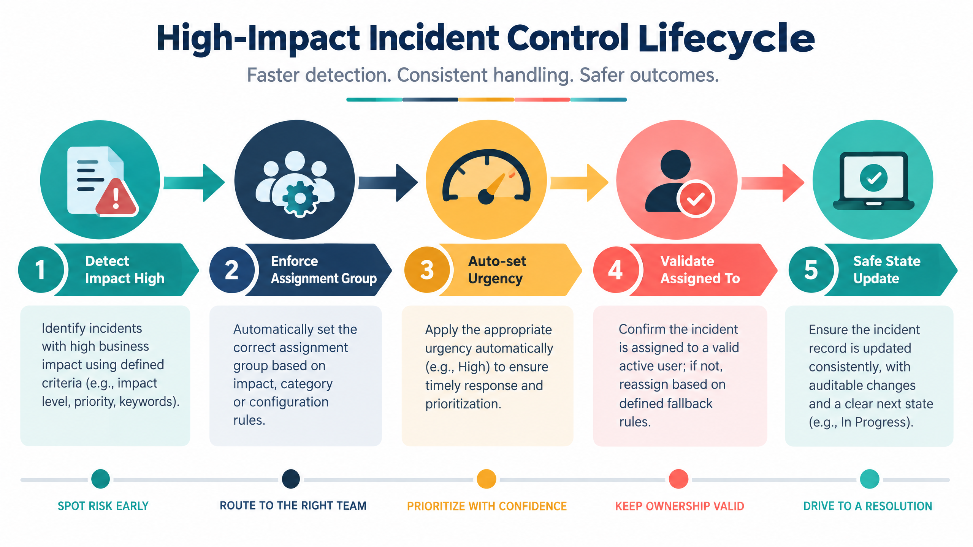
Generated project visual: new Incident control lifecycle from High Impact detection to safe update.
2. Target users and recurring need
User | Situation | Need
Service desk agent | Creating or updating an Incident under time pressure. | Fast, visible guidance with a clear correction path.
Incident manager | Receiving a high-impact record for triage. | Reliable routing, urgency, ownership, and State context.
SLA/reporting owner | Reviewing operational records. | Consistent values and dependable history.
ServiceNow administrator | Maintaining the configuration. | Small, named, reversible, testable controls.
3. Problem–Solution Fit canvas
Canvas area | Incident project answer
Customer problem | High-impact Incident records can be saved or changed with incomplete routing/ownership or inconsistent urgency.
Current behavior | Agents enter Impact, Urgency, Assignment group, Assigned To, and State manually; list editing can bypass form context.
High-cost consequence | Delayed ownership, weaker triage, SLA risk, rework, and unreliable operational reporting.
Desired outcome | High-impact records are complete, urgency is aligned, unsafe State list edits are rejected, and valid form updates remain possible.
Solution | High Impact Control UI Policy plus onChange, onSubmit, and onCellEdit Client Scripts.
Fit signal | Negative tests are blocked; positive tests save; reverse condition restores normal behavior.
Adoption reason | Native ServiceNow behavior, no new platform, no external service, and messages explain the rule.
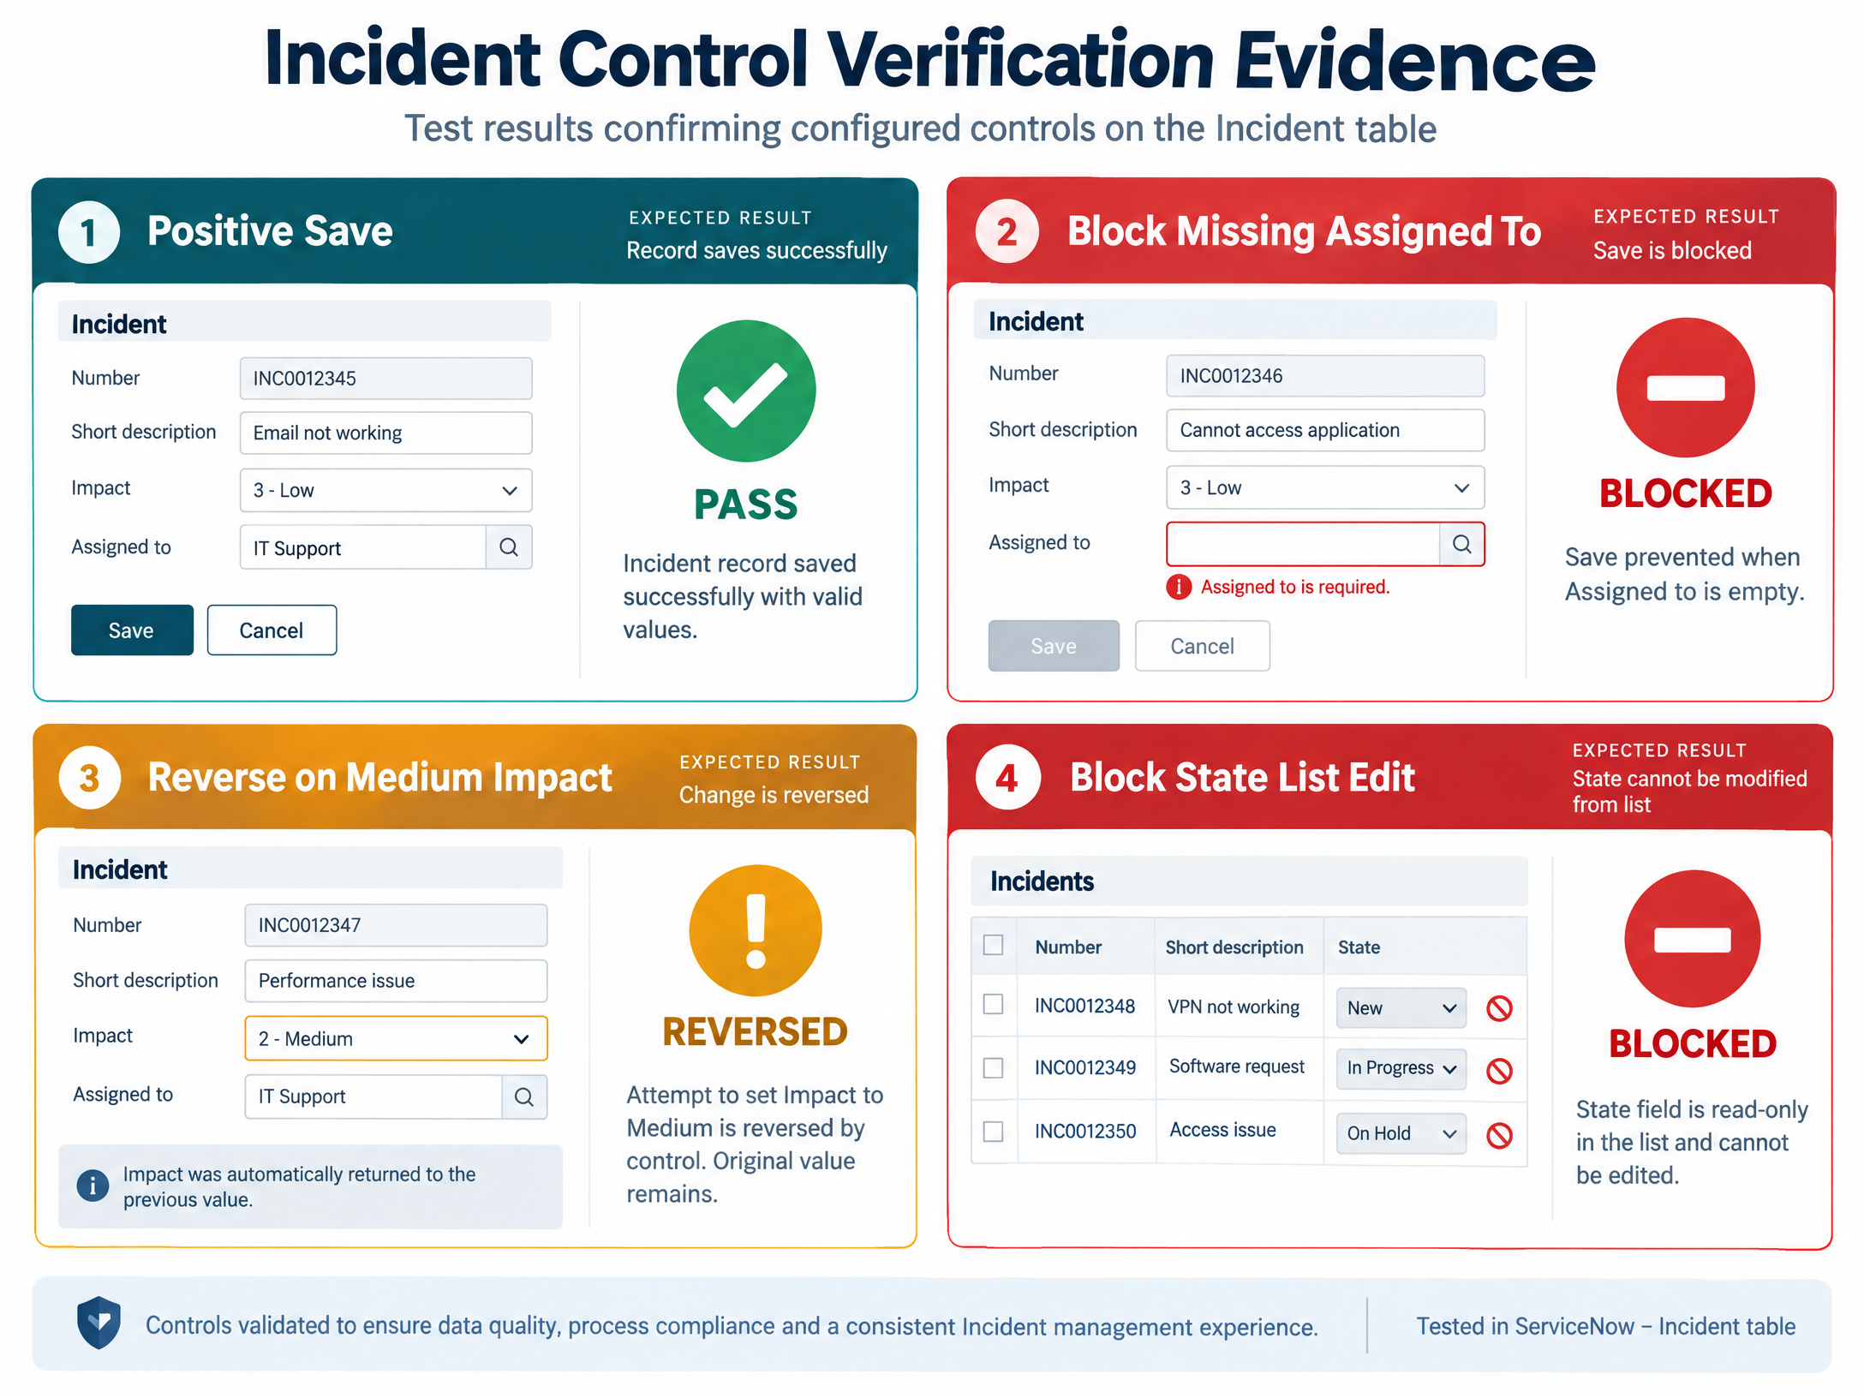
Generated project visual: new verification evidence for positive, negative, reverse, and list-edit scenarios.
4. Value proposition
For service desk teams that need trustworthy high-impact Incidents, the proposed ServiceNow control layer is a native, explainable, reversible solution that guides agents at the moment of risk. Unlike a static checklist, it enforces the rule in the form and list experience; unlike an opaque prediction, every result can be traced to an explicit condition or event script.
5. Alternatives considered
Alternative | Strength | Why not the first choice
Manual checklist | Low implementation effort. | Depends on memory and does not block invalid save.
Server-side-only rule | Strong integration coverage. | Less immediate UI guidance; can be a later hardening layer.
External workflow app | Could centralize complex workflows. | Adds infrastructure for a small native form-governance problem.
AI recommendation | Could suggest priority. | Not needed for explicit rules; less explainable and outside project scope.
UI Policy + Client Scripts | Native, immediate, conditional, reversible, testable. | Selected baseline solution.
6. Fit risks and mitigations
• Client-side controls are not the security boundary: retain ServiceNow ACLs and server-side policies.
• Agents may be surprised by blocked State list edits: provide a clear message and direct them to the form.
• Rules may remain active after Impact changes: set Reverse if false = true and test the transition.
• Field/value changes could break scripts: keep names documented and include regression tests.
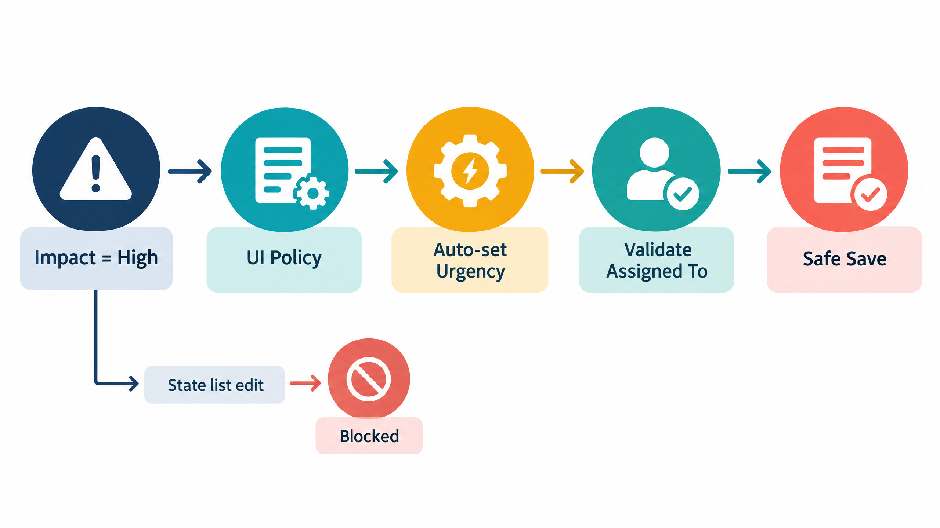
Generated project visual: explicit rule path from Impact condition to automation, validation, or blocked action.
7. Fit conclusion
The solution fits the problem because it directly reduces the failure modes named in the project PDF: incomplete fields, inconsistent urgency, invalid submission, and unsafe list editing. The implementation remains appropriately small for the problem and creates a clear base for later server-side hardening.

